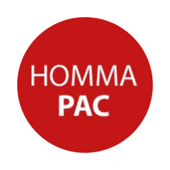
HOT LUNCH PROGRAM 2022-2023
UPDATED ON JANUARY 3, 2023

Dear Homma Families,
With the start of this new school year, we are excited to launch the Homma PAC Hot Lunch Days!
If your family wants to participate in the Homma Hot Lunch Program, please set up an account on https://homma.hotlunches.net/.
All families, new and returning, must create a new account. If you had a previous account, it has been removed from the system to start this new school year. To register, you will need the school access code which is HEHL. Because we receive a large number of questions and have limited volunteers to help with responding to emails, we have compiled a list of common questions for your reference.
Our Hot Lunch Team has worked with a number of vendors to provide a range of food options (including vegetarian and vegan). As per the school policy, we ensure that all food options are nut-free. We do have ingredient information if needed, however, we are not able to guarantee that products are not subjected to cross-contamination while prepared. We do endeavour to provide a robust program with two hot lunch days per month, but we acknowledge that all offerings will not work for all families. Most of the work to set up the Hot Lunch Program is completed in June, July and August, so we are able to gather feedback for the next school year.
We appreciate your generous support for our Homma Hot Lunch program because all of the funds raised go towards classroom equipment, computers, the Homma Garden, library books, educational workshops and school activities for our students.
If you have questions, please let us know.
Thank you,
Jodie Weiler and Anna Reithmeier
On behalf of the Homma PAC
Email: contacthommapac@gmail.com
FREQUENTLY ASKED QUESTIONS

How do I register?
We ask all families (new and returning) to create a new 2022/2023 school year account on https://homma.hotlunches.net/ because all account information is removed from the system over the summer break. Accounts from the last school year (2021-2022) are no longer active.
You can create a Homma Hot Lunch account by using the following instructions:
- Go to: homma.hotlunches.net

- Select “Click Here to Register” link (as shown below) and complete the form to register.
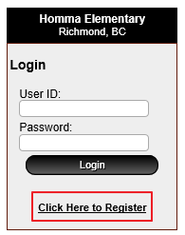
- When registering for an account, you will need our school’s Access Code. Homma’s code is HEHL.
- Please remember your User ID, password and email address for future reference. Use an email address that you regular check as confirmations and reminders will be sent to your inbox.
- Once you have registered, you will be able to add your child(ren) and specify their teacher and division by clicking the “Students” button. Please ensure you select the correct classroom, as this is where the order will be delivered.
- After adding your children, click on “Orders”.
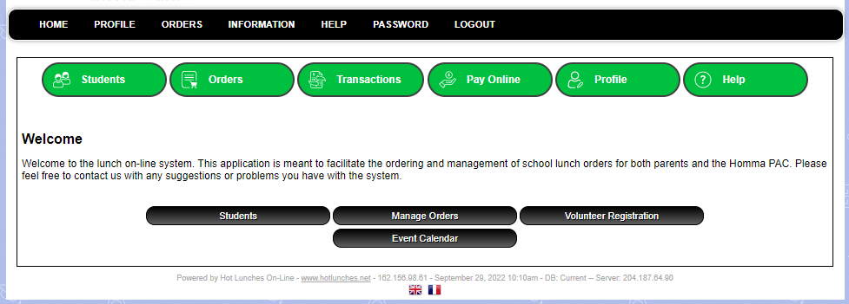

How do I order?
- Under your child(ren)’s name, click “Order” to select their hot lunch items. If you have more than one child you are ordering for, you need to create a separate order for each child.
- Once you have selected your items, click “Update Order & Proceed.”
- All orders must be paid by credit card.
- Check to ensure your “Order Status” is “Paid.”
- Next time you navigate to homma.hotlunches.net, just enter your login information and click the ‘Login’ button to access your account.
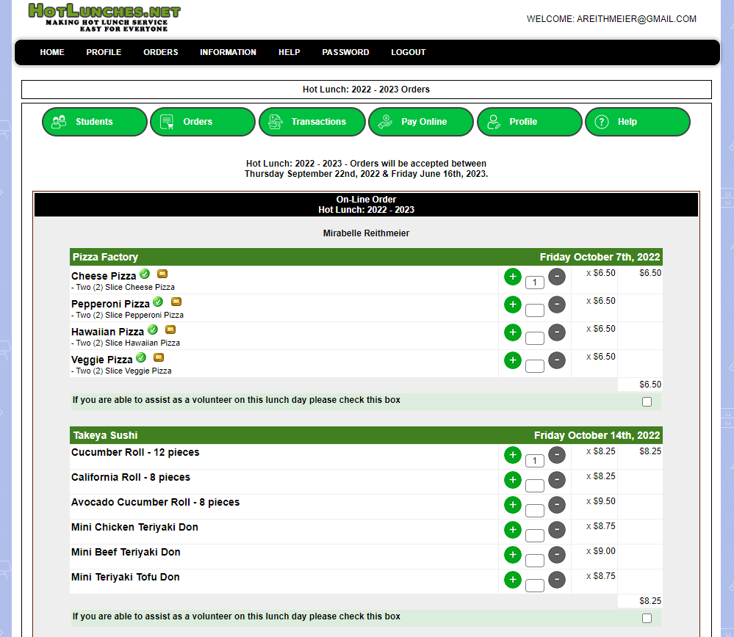

When is the order deadline?
Orders are due on Thursday nights at 9:00 PM.

When are the Hot Lunch Days?
Please note the following planned Hot Lunch Days for Term 2 (January to March). Term 3 dates will be open in late March.
Hot Lunch Day | Vendor | Order Deadline (9 PM)
Friday, January 13 | Pizza Factory | Thursday, January 5
Friday, January 20 | Takeya Sushi | Thursday, January 12
Friday, January 27 | Dairy Queen | Thursday, January 19
Friday, February 3 | Pizza Factory | Thursday, January 26
Friday, February 10 | Dairy Queen | Thursday, February 2
Friday, February 24 | Boston Pizza | Thursday, February 16
Friday, March 3 | Dairy Queen | Thursday, February 23
Friday, March 10 | Pizza Factory | Thursday, March 2

What if I forget to order by the deadline?
Each Hot Lunch Day, we will order a small amount of additional food to sell on the day of. Unfortunately, we cannot guarantee items will be available, as it will be sold first come, first served. Ordering online is the best option, as it guarantees choice and the best prices.

Can I change my order?
Yes, you can cancel your paid order or change any time before the order deadline. Simply click the ͞ button next to the number of your order (please see the red box on the screen shot below). Don’t forget to go to the bottom of the screen and click “Update Order & Proceed” to confirm the change. If you change or cancel an order, any remaining balance will be added to your account as a credit.
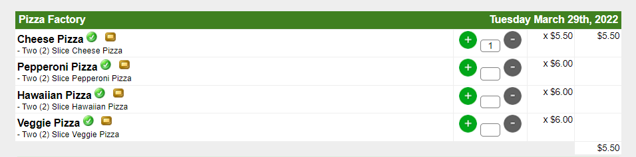

Can I request a refund or a credit for a submitted order?
Consistent with previous years, there are no refunds or cancellations after the order deadline. Because this is a Homma PAC fundraiser that supports the school community, we are not able to process refunds or change orders once they have been sent to our food vendors. We promise that any ordered food will not go to waste and will be shared with the school’s students and staff.
If you would like to arrange to pick up your food from school, please reach out to us in advance. Please note that our volunteers make delivery to the classrooms their first priority. Thank you for your understanding.

What happens if my child is away from school on a Hot Lunch Day?
If your child is away, you can arrange for their order to go to their sibling or you can pick it up at school. To make these arrangements, please email the classroom teacher and copy the Homma Office (homma@sd38.bc.ca) before 10:00 AM. If you plan to pick up the food order, please come to the school at 12:15 PM.
If my family had a credit from last year, will it be applied to this year’s account?
For all cancelled orders, we have applied a credit to your account. Unfortunately, the HotLunches.net site is not designed to show all of the transactions and credits assigned to each account in a user-friendly format, however, when you go to pay for your lunch orders, you should see that a credit is available.

What do I do if I have more questions or concerns?

Please do not contact the Hot Lunch Program vendors to make changes to your order. Please direct all questions to the Homma PAC (contacthommapac@gmail.com).
If you need assistance with ordering, or do not have regular access to the internet, please contact the Homma PAC.

