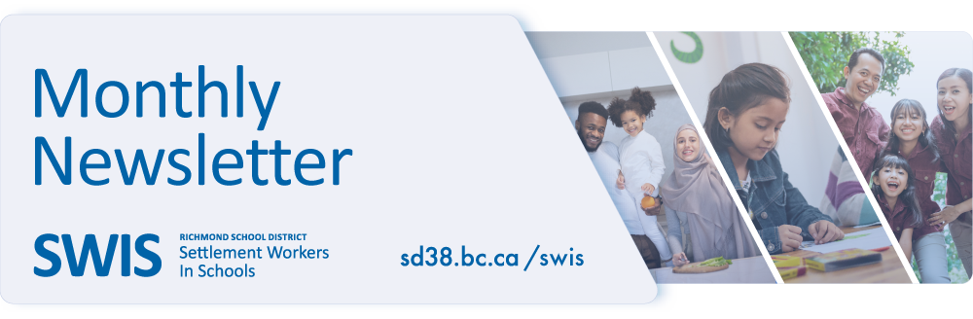

***-Information Sessions –***

***Summer Activities for Children/Youth***

**2024青少年暑期活动**

Learn about the different summer activities for children and youth.  Information includes registration and available subsidies.

**Date**: May 9, 2024 (9:30 – 11am)

**Location**: City Centre Community Centre, Multipurpose Room,  #105 - 5900 Minoru Blvd.

**Language**: English and Chinese Translation（英文讲座附中文翻译)

**Registration:**[https://forms.office.com/r/H9Jjhzz5qt](http://track.spe.schoolmessenger.com/f/a/SgMbIsdwIfLr4gD_xav3Lg~~/AAAAAQA~/RgRoDUivP0QlaHR0cHM6Ly9mb3Jtcy5vZmZpY2UuY29tL3IvSDlKamh6ejVxdFcHc2Nob29sbUIKZiovFSxmmdxQbVIUY2F2ZW5kYW5vQHNkMzguYmMuY2FYBAAAAAI~)

***High School Transition for Grade 7 Students/Families***

Learn more about Richmond secondary schools and how to support your child as they prepare to start

Grade 8 in September.

**Date**: May 16, 2024 (10am – 12pm)

**Location**: Brighouse Richmond Public Library, 2nd Floor Community Place

**Language**: English with Mandarin translation

**Registration**: [https://forms.office.com/r/PSpTFVBw85](http://track.spe.schoolmessenger.com/f/a/5XUQLwohr23uQvBsIgDw7A~~/AAAAAQA~/RgRoDUivP0QlaHR0cHM6Ly9mb3Jtcy5vZmZpY2UuY29tL3IvUFNwVEZWQnc4NVcHc2Nob29sbUIKZiovFSxmmdxQbVIUY2F2ZW5kYW5vQHNkMzguYmMuY2FYBAAAAAI~)

***Information Session – Kindergarten Transition***

Learn more about the Kindergarten program in Richmond schools and how to support your child as they prepare to start Kindergarten in September.

**Date**: May 30, 2024 (10am – 12pm)

**Location**: Brighouse Richmond Public Library, 2nd Floor Community Place

**Language**: English with Mandarin translation

**Registration**: [https://forms.office.com/r/MEadxxCtCd](http://track.spe.schoolmessenger.com/f/a/eMvR4wD010h8IJiA3fPtnw~~/AAAAAQA~/RgRoDUivP0QlaHR0cHM6Ly9mb3Jtcy5vZmZpY2UuY29tL3IvTUVhZHh4Q3RDZFcHc2Nob29sbUIKZiovFSxmmdxQbVIUY2F2ZW5kYW5vQHNkMzguYmMuY2FYBAAAAAI~)